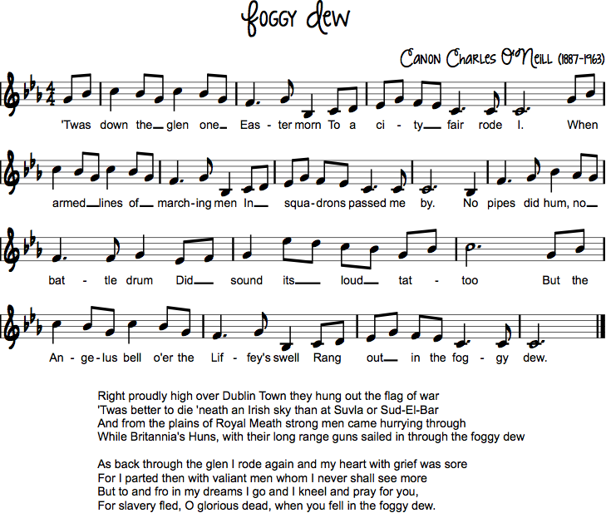

Nr 3

*Twas britannian bade our*[*wild geese*](https://en.wikipedia.org/wiki/Flight_of_the_Wild_Geese)*go, that "small nations might be free";*  
*Their lonely graves are by [Suvla](https://en.wikipedia.org/wiki/Suvla" \o "Suvla)'s waves or the fringe of the great*[*North Sea*](https://en.wikipedia.org/wiki/North_Sea)*.*  
*Oh, had they died by [Pearse](https://en.wikipedia.org/wiki/Patrick_Pearse" \o "Patrick Pearse)'s side or fought with [Cathal Brugha](https://en.wikipedia.org/wiki/Cathal_Brugha" \o "Cathal Brugha)\**  
*Their graves we'd keep where the [Fenians](https://en.wikipedia.org/wiki/Fenian" \o "Fenian) sleep, 'neath the shroud of the foggy dew.*